**Ex.No:13 Roll No:231901002**

**Name: ADHIYAN PERIYAR R P**

**WORKING WITH TRIGGER**

**Program 1**

**Write a code in PL/SQL to develop a trigger that enforces referential integrity by preventing the deletion of a parent record if child records exist.**

CREATE OR REPLACE TRIGGER prevent_parent_deletion

BEFORE DELETE ON employees

FOR EACH ROW

DECLARE pl_dept_count

NUMBER; BEGIN SELECT

COUNT(*)

INTO pl_dept_count

FROM department

WHERE dept_id = :OLD.employee_id;

IF pl_dept_count > 0 THEN

RAISE_APPLICATION_ERROR(-20001, 'Cannot delete employee record as department records exist.'); END IF; END;

DELETE FROM employees

WHERE employee_id = 70;

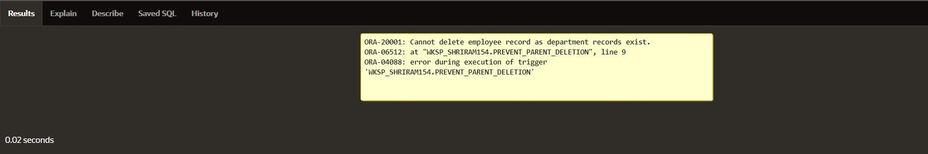

**Write a code in PL/SQL to create a trigger that checks for duplicate values in a specific column and raises an exception if found.**

CREATE OR REPLACE TRIGGER prevent_duplicate_manager_id

BEFORE INSERT OR UPDATE ON employees

FOR EACH ROW

DECLARE pl_count

NUMBER; BEGIN

SELECT COUNT(*)

INTO pl_count

FROM employees

WHERE manager_id = :NEW.manager_id AND employee_id != :NEW.employee_id;

IF pl_count > 0 THEN

RAISE_APPLICATION_ERROR(-20003, 'Duplicate manager_id found: ' ||

:NEW.manager_id); END

IF;

END;

INSERT INTO employees (employee_id, first_name, last_name, email, phone_number, hire_date, job_id, salary, commission_pct, manager_id, department_id)

VALUES (202, 'Jane', 'Smith',

'john006@gmail.com',7383922241,'11/9/2000','ST_CLERK',10000,0.15,400,80);

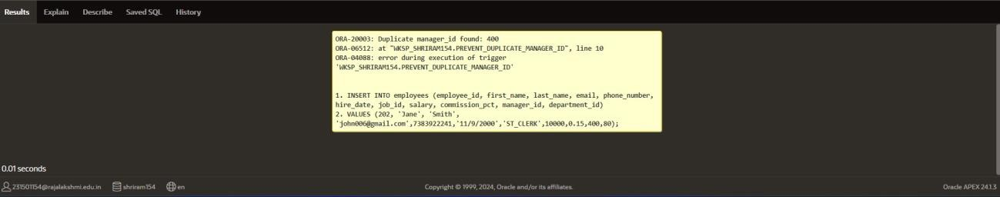

**Write a code in PL/SQL to create a trigger that restricts the insertion of new rows if the total of a column's values exceeds a certain threshold.**

CREATE OR REPLACE TRIGGER restrict_salary_insertion

BEFORE INSERT ON employees

FOR EACH ROW

DECLARE

total_salary NUMBER; threshold NUMBER := 100000; BEGIN

SELECT SUM(salary)

INTO total_salary

FROM employees;

IF (total_salary + :NEW.salary) > threshold THEN

RAISE_APPLICATION_ERROR(-20004, 'Insertion denied: Total salary exceeds the

threshold of ' || threshold); END IF;

END;

INSERT INTO employees (employee_id, first_name, last_name, email, phone_number, hire_date, job_id, salary, commission_pct, manager_id, department_id)

VALUES (203, 'Charlie', 'Brown', 'charlie203@gmail.com', '9122334455','03/01/2021', '#cb203', 5000, 0.20, 1000, 50);

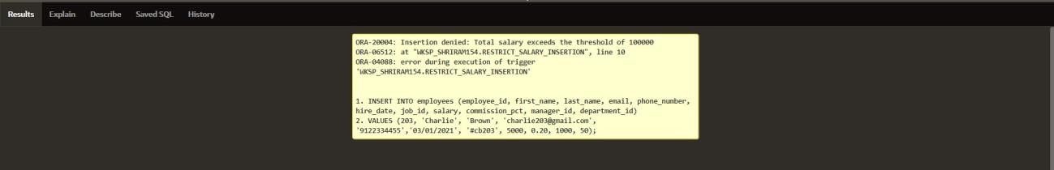

**Write a code in PL/SQL to design a trigger that captures changes made to specific columns and logs them in an audit table.**

CREATE OR REPLACE TRIGGER audit_changes

AFTER UPDATE OF salary, job_id ON employees

FOR EACH ROW

BEGIN

IF :OLD.salary != :NEW.salary OR :OLD.job_id != :NEW.job_id THEN

INSERT INTO employee_audit ( employee_id, old_salary, new_salary, old_job_title, new_job_title, change_timestamp, changed_by

) VALUES (

:OLD.employee_id,

:OLD.salary,

:NEW.salary,

:OLD.job_id,

:NEW.job_id,

SYSTIMESTAMP,

USER

);

END IF;

END;

UPDATE employees

SET salary = 55000, job_id = 'ST_CLERK' WHERE employee_id = 176;

SELECT * FROM employee_audit;

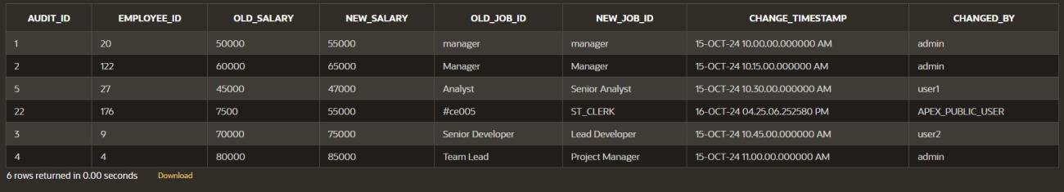

**Program 5**

**Write a code in PL/SQL to implement a trigger that records user activity (inserts, updates,**

**deletes) in an audit log for a given set of tables.**

CREATE OR REPLACE TRIGGER trg_audit_employees

AFTER INSERT OR UPDATE OR DELETE ON employees

FOR EACH ROW

DECLAREv_old_values

CLOB; v_new_values

CLOB;

BEGIN

IF INSERTING THEN v_old_values := NULL; v_new_values :=

'employee_id: ' || :NEW.employee_id || ', ' ||

'first_name: ' || :NEW.first_name || ', ' ||

'salary: ' || :NEW.salary;

INSERT INTO audit_log (action, table_name, record_id, changed_by, new_values)

VALUES ('INSERT', 'employees', :NEW.employee_id, USER, v_new_values);

ELSIF UPDATING THEN

v_old_values := 'employee_id: ' || :OLD.employee_id || ', ' ||

'first_name: ' || :OLD.first_name || ', ' ||

'salary: ' || :OLD.salary; v_new_values :=

'employee_id: ' || :NEW.employee_id || ', ' ||

'first_name: ' || :NEW.first_name || ', ' ||

'salary: ' || :NEW.salary;

INSERT INTO audit_log (action, table_name, record_id, changed_by, old_values, new_values)

VALUES ('UPDATE', 'employees', :NEW.employee_id, USER, v_old_values, v_new_values);

ELSIF DELETING THEN

v_old_values := 'employee_id: ' || :OLD.employee_id || ', ' ||

'first_name: ' || :OLD.first_name || ', ' ||

'salary: ' || :OLD.salary; v_new_values

:= NULL;

INSERT INTO audit_log (action, table_name, record_id, changed_by, old_values)

VALUES ('DELETE', 'employees', :OLD.employee_id, USER, v_old_values); END IF;

END trg_audit_employees;

INSERT INTO employees (employee_id, first_name, salary)

VALUES (3, 'Ball', 50000);

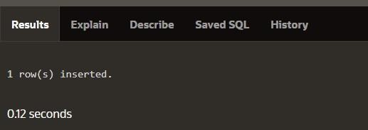

UPDATE employees

SET salary = 55000

WHERE employee_id = 3;

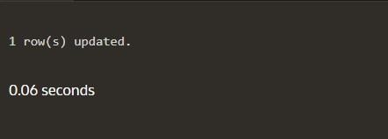

DELETE FROM employees WHERE employee_id = 3;

SELECT * FROM audit_log;

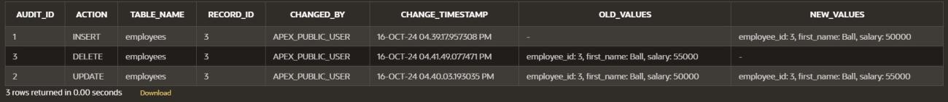

**Program 6**

**Implement a trigger that automatically calculates and updates a running total column for a table whenever new rows are inserted.**

CREATE TABLE transactions ( transaction_id NUMBER PRIMARY KEY, amount NUMBER, running_total NUMBER

);

CREATE OR REPLACE TRIGGER update_running_total

FOR INSERT ON transactions

COMPOUND TRIGGER

TYPE amount_array IS TABLE OF NUMBER INDEX BY PLS_INTEGER; new_amounts amount_array;

BEFORE EACH ROW IS

BEGIN new_amounts(:NEW.transaction_id) :=

:NEW.amount;

END BEFORE EACH ROW;

AFTER STATEMENT IS

BEGIN

DECLARE v_total NUMBER;

BEGIN

SELECT NVL(MAX(running_total), 0)

INTO v_total

FROM transactions;

FOR i IN new_amounts.FIRST .. new_amounts.LAST LOOP v_total

:= v_total + new_amounts(i); UPDATE transactions

SET running_total = v_total

WHERE transaction_id = i;

END LOOP;

END;

END AFTER STATEMENT;

END update_running_total;

INSERT INTO transactions (transaction_id, amount) VALUES (1, 10000);

INSERT INTO transactions (transaction_id, amount)

VALUES (2, 20000);

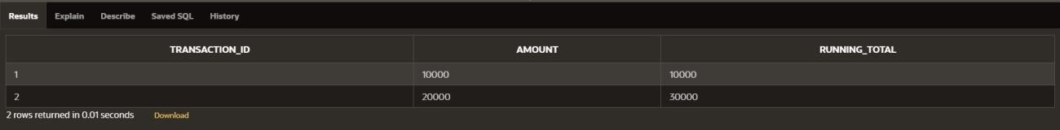

**Program 7**

**Create a trigger that validates the availability of items before allowing an order to be placed, considering stock levels and pending orders.**

CREATE TABLE inventory ( item_id NUMBER PRIMARY KEY, item_name VARCHAR2(100), stock_level NUMBER

);

CREATE TABLE orders ( order_id

NUMBER PRIMARY KEY, item_id NUMBER, quantity NUMBER, order_status VARCHAR2(20),

CONSTRAINT fk_item FOREIGN KEY (item_id) REFERENCES inventory(item_id)

);

CREATE OR REPLACE TRIGGER validate_stock_before_order

BEFORE INSERT ON orders

FOR EACH ROW

DECLARE v_stock_level

NUMBER; v_pending_orders

NUMBER;

BEGIN

SELECT stock_level

INTO v_stock_level

FROM inventory

WHERE item_id = :NEW.item_id;

SELECT NVL(SUM(quantity), 0)

INTO v_pending_orders

FROM orders

WHERE item_id = :NEW.item_id

AND order_status = 'Pending';

IF (:NEW.quantity + v_pending_orders) > v_stock_level THEN

RAISE_APPLICATION_ERROR(-20001, 'Insufficient stock for item: ' || :NEW.item_id); END IF;

END;

INSERT INTO orders (order_id, item_id, quantity, order_status) VALUES (1, 101, 5, 'Pending');

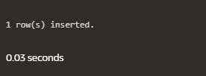

INSERT INTO orders (order_id, item_id, quantity, order_status)

VALUES (2, 103, 20, 'Pending');

